**OOP CA6 Database Queries**

select vehicle_type, vehicle_registration, timestamp, cost from toll_event natural join customer_vehicles natural join customer

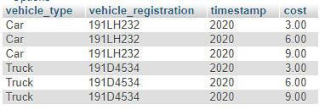NATURAL join vehicle natural join vehicle_type_cost where customer_name = "John Smith";

select sum(cost) from toll_event natural join customer_vehicles natural join customer NATURAL join vehicle natural join vehicle_type_cost where customer_name = "John Smith"

